AI/ML Bootcamp Exercise
Data Analysis and Handling
1. Objective
The goal of this exercise is to practice basic data analysis tasks:
- Loading a dataset
- Finding and removing duplicate rows
- Filling in missing values
- Finding and fixing outliers
- Making simple charts to understand the data
The dataset used is a sample customer dataset with columns: CustomerID, Name, Age, Gender, Annual Income, and Spending Score.

2. Dataset Overview
Sample Data
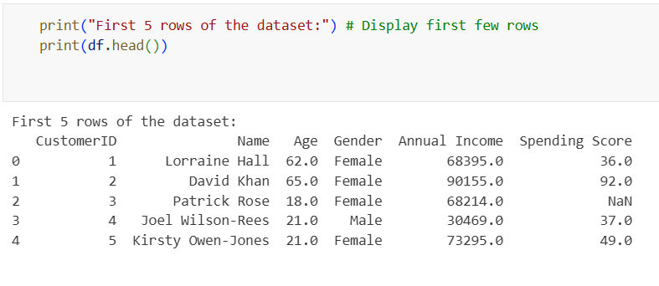
Observations:
- The dataset has 6 rows and 6 columns.
- There is a duplicate row (CustomerID 5).
- Some values are missing in Age and Gender.
- There might be outliers in Annual Income and Spending Score.
3. Loading the Data
We used Python libraries to load and work with the data:
- pandas for working with data
- numpy for calculations
- matplotlib and seaborn for charts

Code:
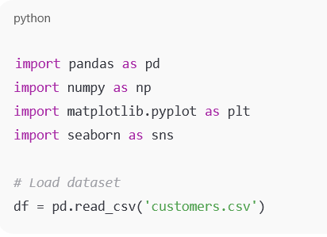
The dataset loaded successfully, and df.info() and df.describe() helped check column types and basic statistics.
4. Duplicate Row Analysis
We looked for duplicate rows across all columns.
Code Example:
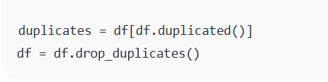
5. Handling Missing Values
We checked which columns had missing values.
Missing values before handling:
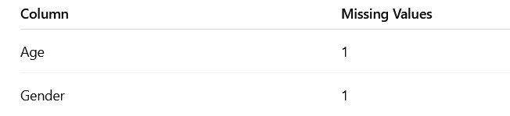
How we fixed it:
- For numbers (like Age), replaced missing values with the median
- For categories (like Gender), replaced missing values with the mode

Code snippet:
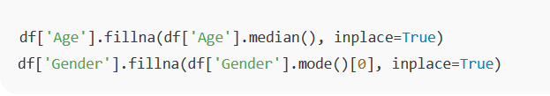
6. Finding and Fixing Outliers
We used the IQR (Interquartile Range) method to find outliers.
- Q1 = 25th percentile, Q3 = 75th percentile
- IQR = Q3 - Q1
- Values below Q1 - 1.5IQR or above Q3 + 1.5IQR are outliers
Code Example to Detect Outliers:
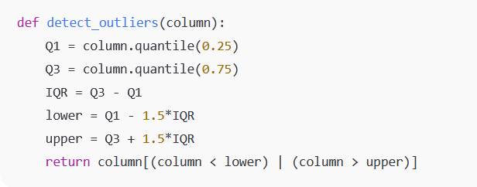
We also made boxplots for Age, Annual Income, and Spending Score to clearly identify outliers.
Fixing Outliers:
- We used Winsorisation:
  - Any value below the lower limit was replaced with the lower limit
  - Any value above the upper limit was replaced with the upper limit
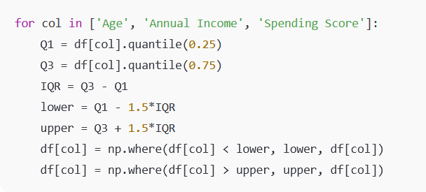
7. Final Cleaned Dataset
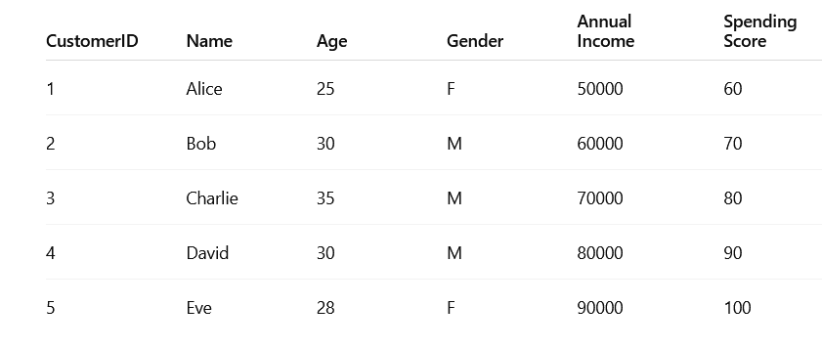
- No duplicate rows
- No missing values
- Outliers handled
8. Charts
- Boxplots show the distribution of Age, Annual Income, and Spending Score and highlight outliers.
- Optional histograms can show the distribution of these numbers.
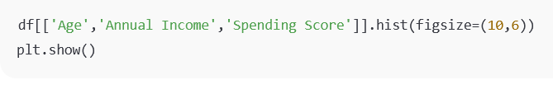
9. Conclusion
- The dataset is clean and ready for analysis.
- Duplicate rows were removed.
- Missing values were filled with median/mode.
- Outliers were detected and fixed.
- Charts help visualise the data and understand it better.
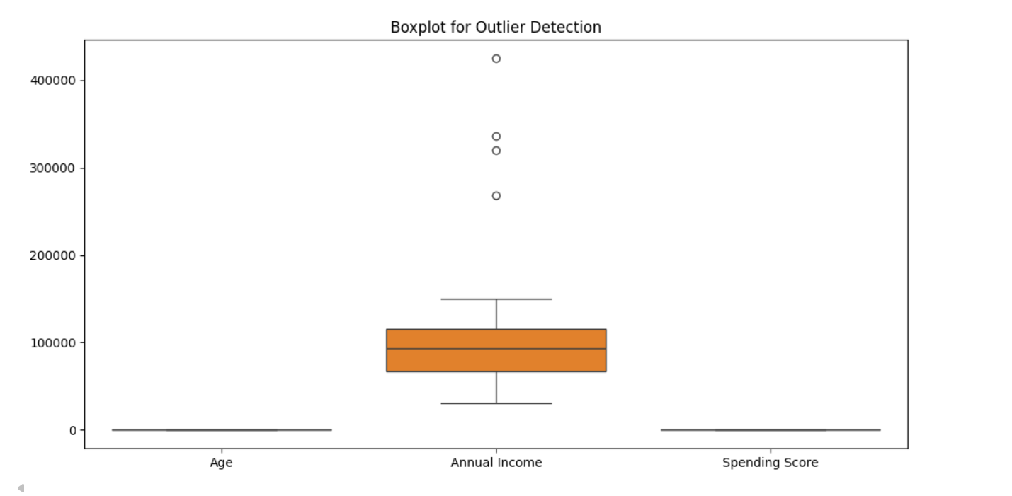

10. Libraries Used
- pandas → for data handling
- numpy → for calculations
- matplotlib & seaborn → for charts

